OGDEN’S ENCYCLOPEDIA OF RADIO HORROR—“V” Copyright © 2012 Vanished Voices OTR
`

V 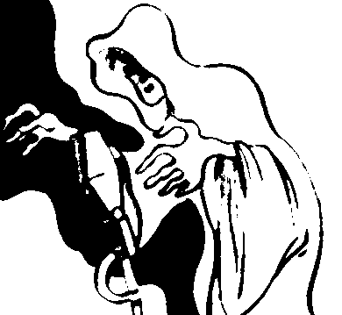

THE VAMPIRE
(RADIO-PLAY)

(CBR, VANCOUVER)
[Thursday—9:00-9:30 PM]
November 26, 1942 “The Vampire”
[VANCOUVER SUN: “… ‘What shape was this that came to us, with mouth so sweet, so poisonous, and tortured hands so pale?--whose eyes have feasted on the dead with mouth so sinister and red—we felt our spirits fall—“…so begins ‘The Vampire,’ a blood-congealing drama that may be heard over CBR, commencing at 9:00 p.m….”]

LES VAMPIRES DE L’ALFAMA
(RADIO-SCRIPT)

[CHRONOLOGY]
SOIREE FANTASTIQUE (FRANCE CULTURE, PARIS)
[
November 26, 1977 “Les Vampires de l’Alfama”
SCRIPT: Catherine Bourdet.
PERSONNEL: Henri Soubeyran (director).
CAST: Marceline Alesse, Jacques Berthier, Jacques Bouvier, Jean Brassat, Evelyne Dandry, Monique Dodd, Ginette Franck, Lucien Fregis, Annick Korrigan, Catherine Laborde, Jean-Pierre Leroux, Marcel Lestan, Georges Lucas, Jacques Maire, Maria May, Albert Medina, Pierre Olivier, Pierre Pernet, Rosy Varte, Yves Vincent.

VINCENT PRICE AND THE HORROR OF THE ENGLISH BLOOD BEAST
⁽RADIO-SCRIPT)

[CHRONOLOGY]
SATURDAY DRAMA (RADIO 4, LONDON—BBC)
[Saturday—2:30-3:30 PM]
March 6, 2010 “Vincent Price and the Horror of the English Blood Beast”
[BBC RADIO 4: “…In 1967, Vincent Price came to the UK to make the horror movie Witchfinder General. It was the best performance of his career, and the worst few months of his life. This play takes a light-hearted look behind the scenes of the making of this classic British film.
SCRIPT: Matthew Broughton.
PERSONNEL: Sam Hoyle (producer-director).
CAST: Kenneth Cranham (Tony Tenser), Nickolas Grace (Vincent Price), Simon Ludders (Actor), Richard Nichols (Philip Waddilove), Gareth Pierce (Ian Ogilvy), Blake Ritson (Michael Reeves), Lynne Seymour (actor), Phoebe Waller-Bridge (Hilary Dwyer).

VLAD THE DRAC
(BOOK)

THE 4 O’CLOCK SHOW (RADIO 4 EXTRA, LONDON)
[Monday-Friday—4:00 PM]
March 11-15. 2012 “Vlad the Drac”
[RADIO 4 EXTRA NEWSLETTER: “…this week’s story features a very naughty little creature called Vlad the Drac. He’s the literary creation of Ann Jungman and his vampire adventures are really great fun…”
PERSONNEL: Elizabeth Clark (Senior Content Producer), Mel Giedroyc (host, reader).

